Sprint 1 - Endurance Design Document

Novemeber 1, 2024

Group Members: Melissa Blanc Doblas, Fabiana Torres, Dabanca Chery, Aiden Ramsay

Table of Contents

[1. Executive Summary. 3](https://live365monmouth-my.sharepoint.com/personal/s1378102_monmouth_edu/Documents/System%20Design%20Document%20Template.docx#_Toc21616852)

[1.1 Project Overview.. 3](https://live365monmouth-my.sharepoint.com/personal/s1378102_monmouth_edu/Documents/System%20Design%20Document%20Template.docx#_Toc21616853)

[1.2 Purpose and Scope of this Specification. 3](https://live365monmouth-my.sharepoint.com/personal/s1378102_monmouth_edu/Documents/System%20Design%20Document%20Template.docx#_Toc21616854)

[2. Product/Service Description.. 3](https://live365monmouth-my.sharepoint.com/personal/s1378102_monmouth_edu/Documents/System%20Design%20Document%20Template.docx#_Toc21616855)

[2.1 Product Context. 3](https://live365monmouth-my.sharepoint.com/personal/s1378102_monmouth_edu/Documents/System%20Design%20Document%20Template.docx#_Toc21616856)

[2.2 User Characteristics. 3](https://live365monmouth-my.sharepoint.com/personal/s1378102_monmouth_edu/Documents/System%20Design%20Document%20Template.docx#_Toc21616857)

[2.3 Assumptions. 3](https://live365monmouth-my.sharepoint.com/personal/s1378102_monmouth_edu/Documents/System%20Design%20Document%20Template.docx#_Toc21616858)

[2.4 Constraints. 3](https://live365monmouth-my.sharepoint.com/personal/s1378102_monmouth_edu/Documents/System%20Design%20Document%20Template.docx#_Toc21616859)

[2.5 Dependencies. 4](https://live365monmouth-my.sharepoint.com/personal/s1378102_monmouth_edu/Documents/System%20Design%20Document%20Template.docx#_Toc21616860)

[3. Requirements. 4](https://live365monmouth-my.sharepoint.com/personal/s1378102_monmouth_edu/Documents/System%20Design%20Document%20Template.docx#_Toc21616861)

[3.1 Functional Requirements. 5](https://live365monmouth-my.sharepoint.com/personal/s1378102_monmouth_edu/Documents/System%20Design%20Document%20Template.docx#_Toc21616862)

[3.2 Security. 5](https://live365monmouth-my.sharepoint.com/personal/s1378102_monmouth_edu/Documents/System%20Design%20Document%20Template.docx#_Toc21616863)

[3.2.1 Protection. 5](https://live365monmouth-my.sharepoint.com/personal/s1378102_monmouth_edu/Documents/System%20Design%20Document%20Template.docx#_Toc21616864)

[3.2.2 Authorization and Authentication. 6](https://live365monmouth-my.sharepoint.com/personal/s1378102_monmouth_edu/Documents/System%20Design%20Document%20Template.docx#_Toc21616865)

[3.3 Portability. 6](https://live365monmouth-my.sharepoint.com/personal/s1378102_monmouth_edu/Documents/System%20Design%20Document%20Template.docx#_Toc21616866)

[4. Requirements Confirmation/Stakeholder sign-off. 6](https://live365monmouth-my.sharepoint.com/personal/s1378102_monmouth_edu/Documents/System%20Design%20Document%20Template.docx#_Toc21616867)

[5. System Design.. 6](https://live365monmouth-my.sharepoint.com/personal/s1378102_monmouth_edu/Documents/System%20Design%20Document%20Template.docx#_Toc21616868)

[5.1 Algorithm.. 6](https://live365monmouth-my.sharepoint.com/personal/s1378102_monmouth_edu/Documents/System%20Design%20Document%20Template.docx#_Toc21616869)

[5.2 System Flow.. 6](https://live365monmouth-my.sharepoint.com/personal/s1378102_monmouth_edu/Documents/System%20Design%20Document%20Template.docx#_Toc21616870)

[5.3 Software. 6](https://live365monmouth-my.sharepoint.com/personal/s1378102_monmouth_edu/Documents/System%20Design%20Document%20Template.docx#_Toc21616871)

[5.4 Hardware. 6](https://live365monmouth-my.sharepoint.com/personal/s1378102_monmouth_edu/Documents/System%20Design%20Document%20Template.docx#_Toc21616872)

[5.5 Test Plan. 7](https://live365monmouth-my.sharepoint.com/personal/s1378102_monmouth_edu/Documents/System%20Design%20Document%20Template.docx#_Toc21616873)

[5.6 Task List/Gantt Chart. 7](https://live365monmouth-my.sharepoint.com/personal/s1378102_monmouth_edu/Documents/System%20Design%20Document%20Template.docx#_Toc21616874)

[5.7 Staffing Plan. 7](https://live365monmouth-my.sharepoint.com/personal/s1378102_monmouth_edu/Documents/System%20Design%20Document%20Template.docx#_Toc21616875)

# **1.** **Executive Summary**

## **1.1** **Project Overview**

The project's overall purpose is for students to better understand the use of algorithms and implementation of block coding while creating an algorithm that meets project standards and requirements. The intended audience is students, staff, and the professor.

## **1.2** **Purpose and Scope of this Specification**

In scope:

Project Manager- Melissa Blanc Doblas

Project purpose- Successfully understand and implement block coding techniques to ensure the given robot is capable of meeting all project standards and requirements

Project objectives-

1. Develop specialized algorithms for robots to follow and carry out correctly
2. Provide user-friendly algorithm for students and faculty members
3. Implement features to track and monitor group member performance and capabilities
4. Integrate algorithm for the robot to carry out deviated path correctly
5. Ensure the system of steps is created and tested in a timely manner
6. Ensure system steps meet requirements and standards

Project constraints-

1. The inefficient battery life of the robot given to the group
2. Compliance with requirements and standards
3. Completion date of November 1st, 2024
4. Limited access to classroom testing area
5. Group member testing times are limited to “when available” due to outside factors

# **2.** **Product/Service Description**

* The most prevalent factor regarding the effects on the product is going to be the Sphero’s battery life. The battery life of the Sphero is short, making testing somewhat difficult at times. Having to charge the Sphero mid-test run significantly decreases group productivity and efficiency.
* The second factor that limits the Sphero’s ability to perform is the tape outline on the floor. During different stages of the test, the Sphero will be thrown off course because of imperfections in the tape, tampering with the operation of the robot.
* The third and final factor that negatively affects the robot's efficiency is the Sphero app. The Sphero app limits the number of algorithmic steps that can be used to blockcode the robot. This limits the user’s ability to fine-tune robot operation.

**2.1** **Product Context**

## **2.2** **User Characteristics**

|  |  |  |  |
| --- | --- | --- | --- |
| **User** | **Experience** | **Technical Expertise** | **General characteristics** |
| Student | None | Not a lot of knowledge about the product | Students might find the product interesting based on their major |
| Faculty | 1-15 years min | Some knowledge | Show attention depending on their level of interest |
| Staff | None | Not a lot of knowledge about the product | Might show some interest depending on what kind of staff (School Administrators, IT Support) |

## **2.3** **Assumptions**

* Sphero Edu and Spark robots need to work. One can not function without the other.
* Charger included, without one will delay the project
* It can speak, if it could not then requirement “must say ready set go before” can not be achieved
* The color can be changed, if it could not requirement “Colors should be red at the end” can not be achieved
* Has the correct functions to go in a start line, if not requirement of following the course laid out on the floor can not be completed

## **2.4** **Constraints the SPRK**

* Describe any items that will constrain the design options,
* We have connectivity constraints (bluetooth range and signal interference)
* Device compatibility (relies in bluetooth )
* Dependency on shpero edu app
* Programming Language support (it support block-based coding)
* Battery life and power constraints
* Limited onboard sensors
* Rounded design limitations (the shape of the sprk+)
* Surface requirements (smooth surfaces needed . rough or uneven surface may impede its movement or affect sensor readings.)

· **2.5** **Dependencies**

* The robot will need to be fully charged for the full duration of the operation
* The robot will require download the sphero app
* The robot will require to connect with the sphero app
* Mobility system affect the requirements .
* The robot will need to be aim in the right direction
* Control the algorithm
* microcontroller/processor feed that affect the responsiveness of line-following algorithms
* Line following requirements so the robot can follow the desired path
* Real time operating system
* Hardware and software and connection types more suitable for the robot

# **3.** **Requirements**

·

## **3.1** **Functional Requirements**

|  |  |  |  |  |  |
| --- | --- | --- | --- | --- | --- |
| Req# | Requirement | Comments | Priority | Date Rvwd | SME Reviewed / Approved |
| Requirement 1-Endurance | Get appropriate Sphero app for device | Each member downloads app | High | 10/25 | Approved |
| Requirement 2-Endurance | Connect robot | Make sure Bluetooth is enabled on the device | High | 10/25 | Approved |
| Requirement 3-Endurance | Make sure the robot moves/functions properly | Make sure the commands given work correctly | High | 10/25 | Approved |
| Requirement 4-Endurance | Find the right commands that will guide the robot | Find right commands so robot travels successfully | High | 10/25 | Approved |
| Requirement 5-Endurance | Use of correct speed | The robot’s speed will be adjusted based on how it responds to the command (too fast/slow) | Medium | 10/25 - 10/31 | Approved |
| Requirement 6-Endurance | Correct AIM | The robot’s AIM should be straight or it’ll go off the path | Low | 10/25 - 10/31 | Approved |
| Requirement 7-Endurance | Correct heading | Make sure it is at a correct angle | High | 10/25 - 10/31 | Approved |

## **3.2** **Security**

### **3.2.1** **Protection**

### **3.2.2** **Authorization and Authentication**

## **3.3** **Portability**

* The Use of block coding limits software portability
* To control and command the robot, an app is required. This limits user freedom to what the app is capable of doing. This also limits the robot's ability to perform because of the variables set by the creators of the Sphero robot.

# **4.** **Requirements Confirmation/Stakeholder sign-off**

:

|  |  |  |
| --- | --- | --- |
| Meeting Date | Attendees (name and role) | Comments |
| 10/25/24 | Melissa Blanc Doblas - Manager  Aiden Ramsay - Collaborator  Dabanca Chery - Collaborator  Fabiana Torres - Collaborator | * Get appropriate Sphero app: Approved * Connect Robot: Approved * Make sure robot moves properly: Approved |
| 10/28/24 | Melissa Blanc Doblas - Manager  Aiden Ramsay - Collaborator  Dabanca Chery - Collaborator  Fabiana Torres - Collaborator | * Find right commands: Approved |
| 10/30/24 | Melissa Blanc Doblas - Manager  Aiden Ramsay - Collaborator  Dabanca Chery - Collaborator  Fabiana Torres - Collaborator | * Correct speed: approved * Correct AIM: approved * Correct heading: approved |
| 10/31/24 | Melissa Blanc Doblas - Manager  Aiden Ramsay - Collaborator  Dabanca Chery - Collaborator  Fabiana Torres - Collaborator | * Correct speed: approved * Correct AIM: approved * Correct heading: approved |

# **5.** **System Design**

## **5.1** **Algorithm**

## The block code in JavaScript

## 

## **5.2** **System Flow**

## **5.3** **Software**

The language that was used to create the products was blocked language which is provided through the Sphero Edu app.

The photo provided below is the block code.

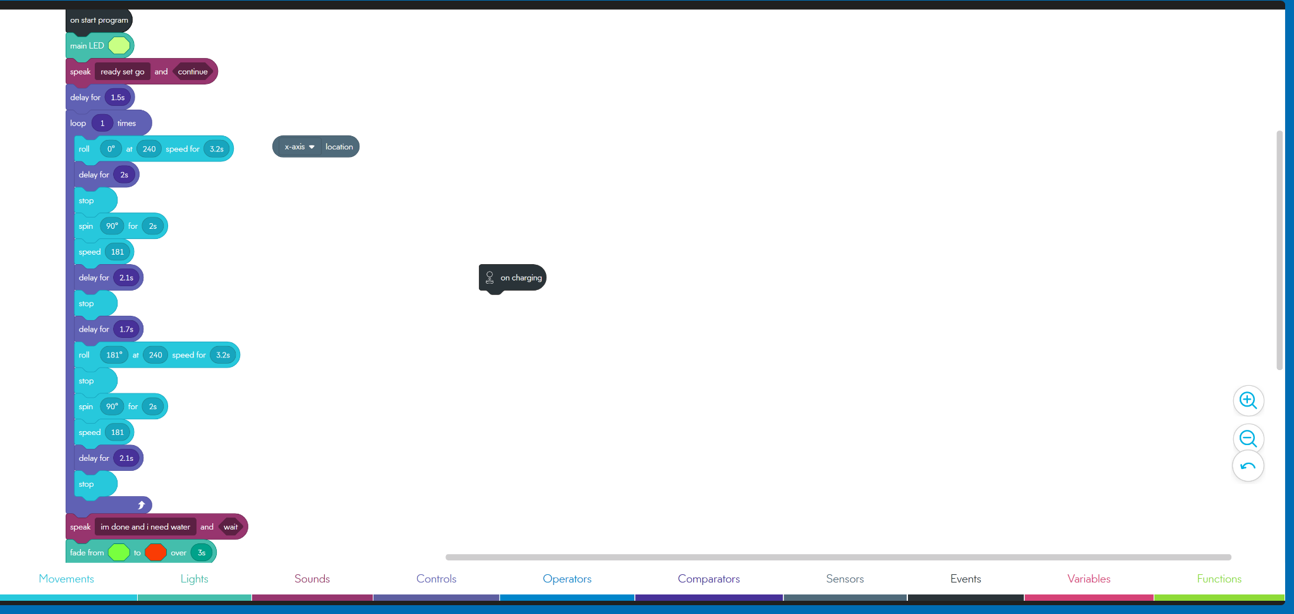

## **5.4** **Hardware**

* We used an encased sphere design robot
* Bluetooth connectivity
* Led light
* Internal motors and gyroscope
* Sensors
* Battery
* Bluetooth compatibility
* The sphero app

## **5.5** **Test Plan**

|  |  |  |  |  |  |
| --- | --- | --- | --- | --- | --- |
| **Reason for Test Case** | **Test Date** | **Expected Output** | **Observed Output** | **Staff Name** | **Pass/Fail** |
| Testing to see which one it will go. | 10/25/24 | Go start forward | When backwards | Melissa, Fabiana,Dabanca, Aiden | Fail |
| Testing to see how far 10 goes at 255 speed | 10/25/24 | Would stop a little off the course | Reached the end of the room | Melissa, Fabiana, Dabanca, Aiden | Fail |
| Testing roll 169 at 255 speed for 5s. Aim in the back | 10/25/24 | Would end at the line and would go in a straight line. | Went in a decent straight line but it went to far | Melissa, Fabiana,Dabanca, Aiden | failed |
| Added voice to say ready set go. .Change seconds to 3.3 | 10/25/24 | Stopped at the correct end.  Sound comes robot | Stopped at the correct end.  Sound comes from laptop (medium) | Melissa, Fabiana,Dabanca, Aiden | passed |
| Change heading to zero, speed 240 for 3.2s. Change aim. | 10/28/24 | Go straight down and stop at the end marking. | Go straight down and stop at the end marking. | Melissa, Fabiana,Dabanca, Aiden | passed |
| Add spin 90 for 2s speed 181 | 10/28/24 | stop and go to the right and end a little off | Stop and spinned and went a little left spinning | Melissa, Fabiana,Dabanca, Aiden | failed |
| Add delay for 1.5s and add stop before | 10/30/24 | Stop for 2s and go to next checkpoint | Stops and go right. Stop halfway | Melissa, Fabiana,Dabanca, Aiden | failed |
| Change Delay 2.1 | 10/30/24 | Stop at the checkpoint going right | Stop at the checkpoint | Melissa, Fabiana,Dabanca, Aiden | Passed |
| Add new delay 1.7, roll 181 at 240 speed for 3.2s, stop | 10/30/24 | Once at the new checkpoint, go upwards and meet the checkpoint | Once at the new checkpoint, go upwards and meet the checkpoint | Melissa, Fabiana,Dabanca, Aiden | passed |
| Add spin 90 for 2s speed 181, delay 2.1, stop | 11/1/24 | Go to the next checkpoint and go to back to the starting point | Went a little off the checkpoint, went back to the starting point. | Melissa, Fabiana,Dabanca, Aiden | passed |
| Add from speak “im done and i need water” and continue green to red over 3s | 11/1/24 | Once it gets to the starting point ill speak and then change color green to red | Once it gets to the starting point ill speak and then change color green to red | Melissa, Fabiana,Dabanca, Aiden | passed |

## **5.6** **Task List/Gantt Chart**

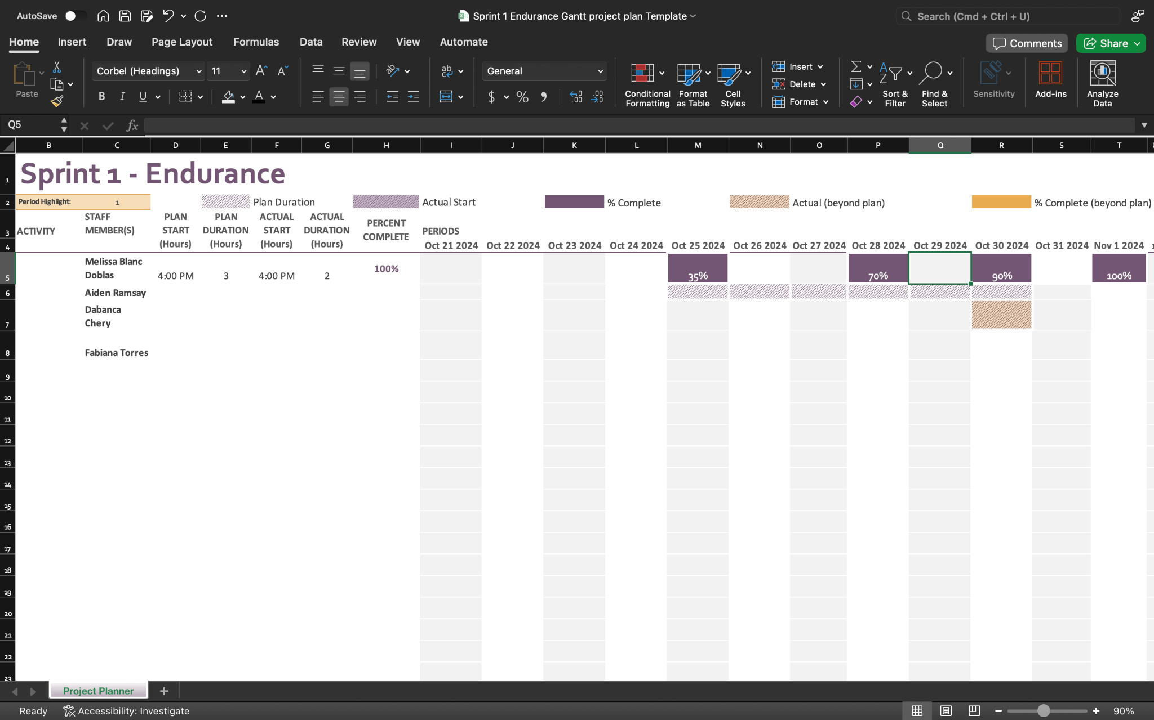

## **5.7** **Staffing Plan**

|  |  |  |  |
| --- | --- | --- | --- |
| Name | Role | Responsibility | Reports To |
| Melissa Blanc Doblas | Manager | Github repo, Staffing Plan, Test Planning, Software, Assumptions |  |
| Fabiana Torres | Collaborator | Gantt Chart, 3,4 Requirement, User characteristic | Manager |
| Aiden Ramsay | Collaborator | Algorithm, Portability, EDD, product descriptions, purpose and scope | Manager |
| Dabanca Chery | Collaborator | System flow, Hardware, Dependencies, Constraints | Manager |